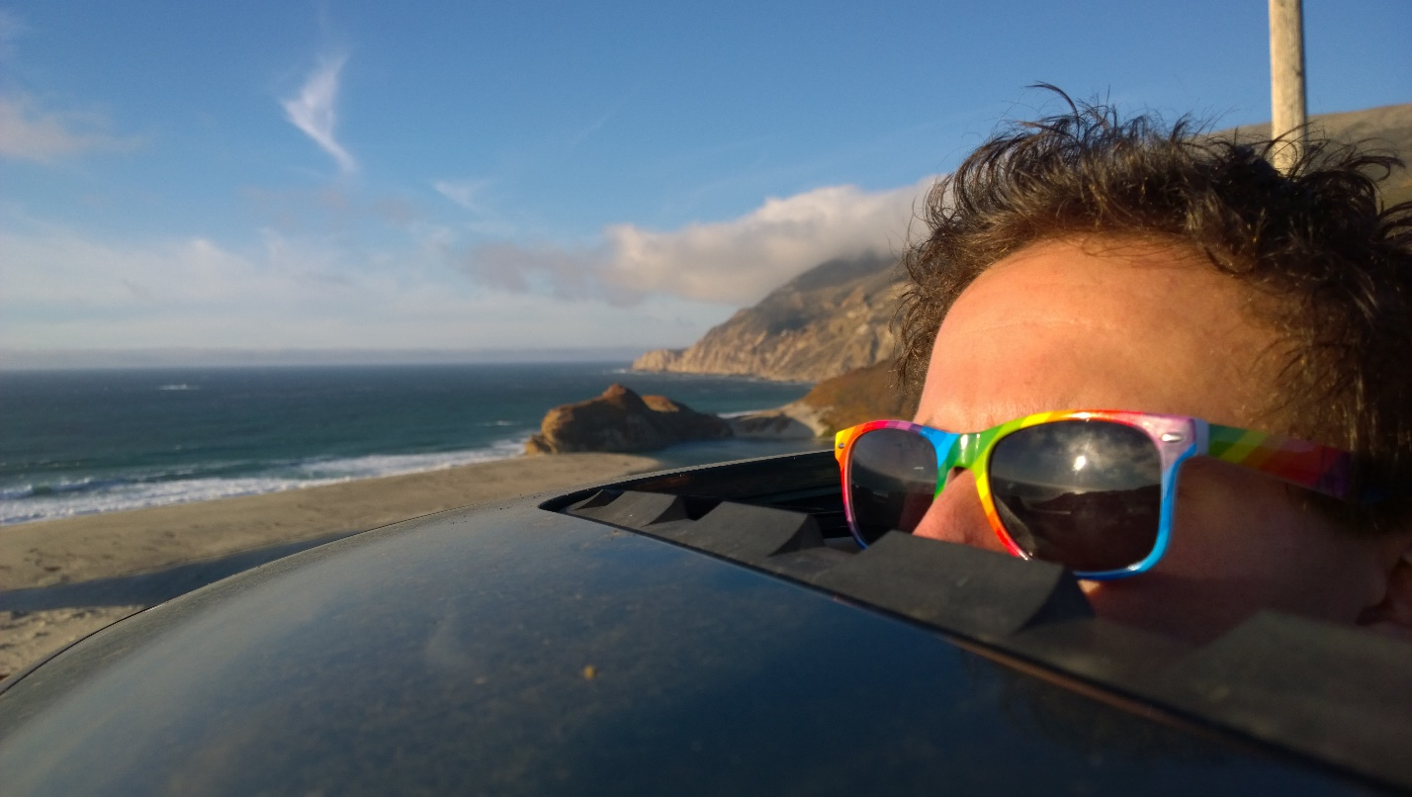 Menu

Home

Voice Over

Stunts

Motion Capture

Contact

Acting

Hi, I’m Alex

Bi-Coastal Voice Over Artist, Stunt Performer, and Motion Capture Actor

Currently Los Angeles-based, and also local to San Francisco & Washington, D.C.

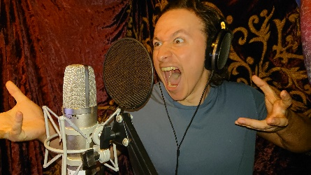

Voice Over

Versatile VO for Animation, Video Games, ADR, and More

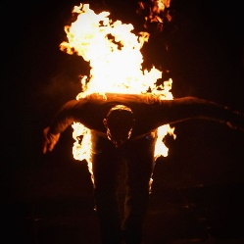

Stunts

Death-Defying Stunts for TV/Film & Live-Shows

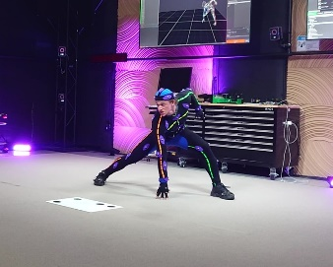

Motion Capture Performer

Creatures & Characters for Virtual Production

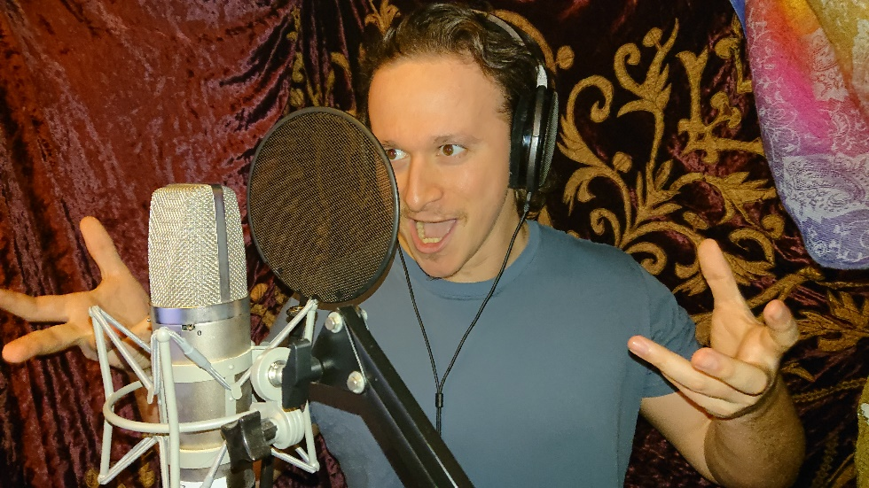Alex Bankier - VO Artist

Versatile custom voice over provided at affordable rates without

compromising quality

Conversational, Animated, Eloquent

Four years spent training and working in Los Angeles for animation, live-action dubbing, commercials, video games, etc. have allowed me the opportunity to work with and learn from some of the best in the industry. Whether your project needs an expert brand advocate or versatile character actor, I can guarantee a memorable complement to the story you are looking to tell.

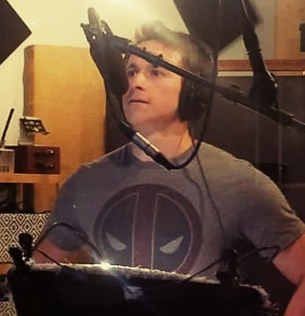

Commercial Reel

Character & Accent Demo

Audiobook Narration Sample

French VO Reel

Motti Wolkenbruch Visual Reel

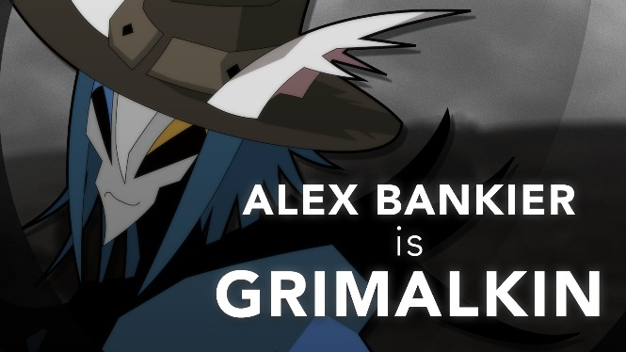

Recent Credits:

Grimalkin – Catalyst Wake (LockedOn Games)

Mordred Mulliner – The Fiery Wooing of Mordred (StoryLight Podcast)

Tommy – The Blue Door (Tales From Your Mom’s Basement Podcast)

VO Training & Instruction:

Video Games - Valerie & Keith Arem (PCB Studios)

Animation Dubbing - Tony Oliver & Julie Maddalena (Adventures in Voice Acting)

ADR & Looping - Johnny Gidcomb, The Voxernauts

Full resume and references available upon request

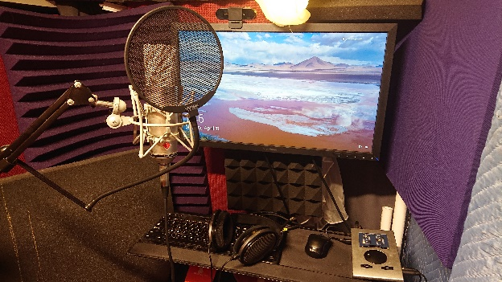

**Broadcast Quality Home Studio:**

Stam SA-87 Microphone w/ Stedman Proscreen XL Pop Filter

RME Babyface Pro FS Audio Interface

Cocko’s Reaper (DAW)

Alienware 17 R5 Laptop w/ External Monitor, Keyboard, and Mouse

Treated Recording Booth (Acoustic Foam, Blankets, Panels, LENRD Bass Traps)

**Connectivity:**

Source Connect Standard

Skype

Zoom

Satisfied Customers

[Satisfied Client Quotes (automated to rotate between several selected ones)]